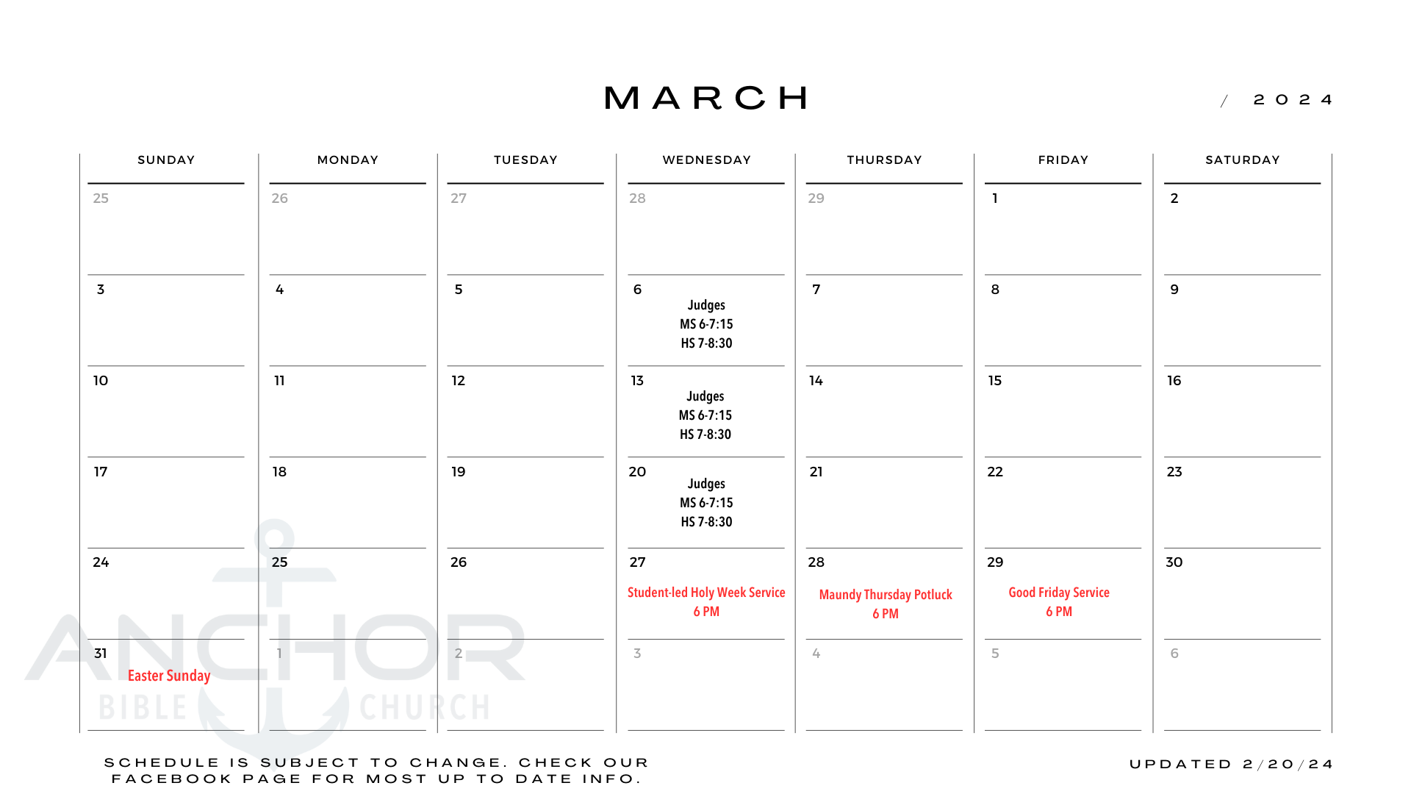D6 Middle School and High School
March 2024 Newsletter

Wednesday March 6th, 13th, 20th – Judges: Israel’s Wild West
This three-week study focuses on some of the highlights (or lowlights) from the book of Judges. We will discuss the universal and unchanging nature of sin in the human condition and what Jesus has done to defeat it.

Wednesday March 27th – Student-led Holy Week Service
Join us for a night of reflection upon the passion narrative as our confirmation students present their Gospel mime.

For the most up to date information on our middle school and high school ministries, please visit www.anchorbibleia.org/student-ministry

Summer Games 2024 Registrations
Registrations are now open for SGU2024! Visit www.sgu.camp to register.

