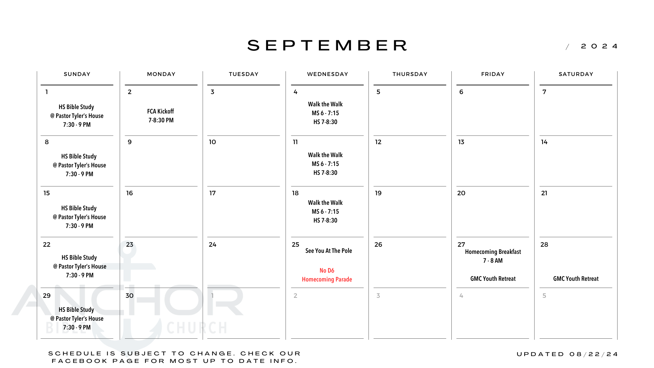D6 Middle School and High School
September 2024 Newsletter

Monday September 1st – FCA Kickoff
High school students are invited out to the Salows’ place for yard games, snacks, and fellowship as we kick off the 2024/25 school year in Fellowship of Christian Athletes.

Wednesday September 4th, 11th, 18th – Walk the Walk
To kick off the year we will be doing a youth study that runs concurrently with the churchwide study discussing the marks of a disciple. Middle school meets 6-7:15 PM. High school meets 7-8:30 PM.

Wednesday August 25th – See You at the Pole
Students are invited to gather at the Fross Park flagpole to pray for our school, community, and nation at 7:45 AM. Afterwards students are invited to Anchor Bible for donuts, fruit, and juice before school.

Friday August 27th – Homecoming Breakfast
High school students, and all district staff are invited to attend a breakfast of pancakes, eggs, fruit, and biscuits and gravy before school!

Friday August 27th & Saturday August 28th - GMC Youth Retreat
We’ll gather with youth from other GMCs for a weekend of worship, discipleship, and lots of fun. We will be staying overnight at Camp Bear Creek in Wyoming, IA. Contact P. Tyler for info on registering!

